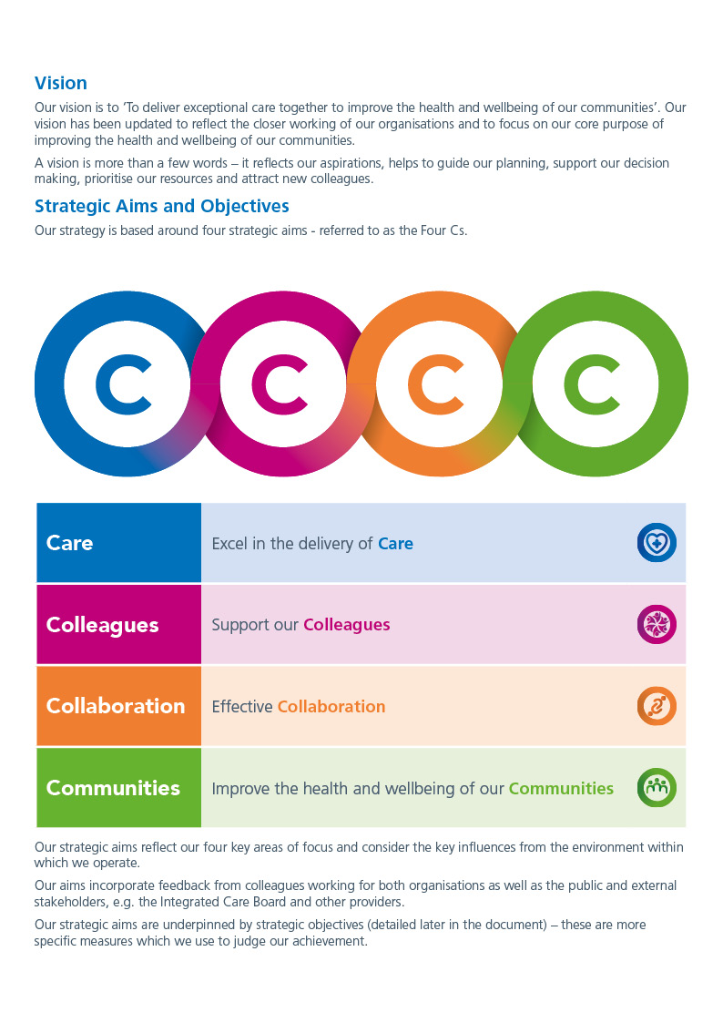

Job Description

1. **Job Details**

|  |  |
| --- | --- |
| **Job Title:** | Senior Clinical Support Worker |
| **Band:** | Band 3 |
| **Reports to (Title):** | Ward/Department/ Manager |
| **Trust Website:** | [www.royalwolverhampton.nhs.uk](http://www.royalwolverhampton.nhs.uk) |
| **Directorate:** |  |
| **Department / Ward:** |  |
| **JD Number:** | 5835 |
| **DBS Check Required:** | Enhanced DBS |

1. **Job Summary**

|  |
| --- |
| The Senior Clinical Support Worker will:   * Be an integral member of the ward/department team working under the direct or indirect supervision of a registered practitioner. * Be responsible for providing care to patients as delegated by the registered practitioner following the completion of specific competencies. * Contribute to the maintenance of care environment and quality initiatives to enhance patient care. * Ensure that their practice adheres to policies, procedures and competencies. * Act in a manner that upholds privacy, dignity, respect and confidentiality of patients and colleagues |

1. **Main Duties and Responsibilities**

|  |
| --- |
| **Personal Care Duties**   * Welcome and orientate patients, carers, relatives, and other visitors to the ward/department always demonstrating care and compassion. * Report any observed changes in the patient’s physical or psychological needs to the registered practitioner. * Provide support to the registered practitioner, and as required by other members of the ward / department clinical team. * Initiate and participate with emergencies i.e. cardiac arrest, patient falls and patients with a rapidly deteriorating condition. * Undertake transfer/escort of patients from one area to another within scope of practice and after appropriate delegation from the registered practitioner. * Undertake Care after Death for deceased patients ensuring that all religious and cultural wishes are adhered with. * Assist in the maintenance of the patient’s individual hygiene requirements, including supporting/ undertaking fundamental patient care, such as washing, dressing, skin care, oral care, hair care, nail care etc. Ensure any concerns or changes in the patients' condition are reported to the registered practitioner. * Ensure pro-active measures are in place to support the prevention of pressure ulcers, complete required documentation and report any concerns or changes in skin integrity to the registered practitioner. * Ensure safe and effective use of equipment and other aids deployed to assist patient movement and mobility e.g. walking aids, hoists etc. * Complete the taking and recording of physiological observations on appropriate IT/paper system (temperature, pulse, blood pressure, respiration, oxygen saturation and blood glucose monitoring), reporting changes to registered practitioner. * Perform ECG recording (as instructed by registered practitioner) in line with local policy/procedure following completion of appropriate competence. * Adhering to aseptic technique apply simple dressings. * Perform phlebotomy (as directed by registered practitioner) in line with national standards and local policy and guidance following completion of appropriate competence.   **Nutrition and Hydration**   * Assist in the preparation of patients prior to meals and beverages, providing assistance with feeding / drinking where appropriate. * Correctly record and monitor dietary and fluid intake of patients, informing registered practitioners of progress and / or any difficulties relating to dietary / fluid intake experienced by the patient.   **Communication**   * + Communicate effectively and maintain good relationships with patients, relatives, and healthcare practitioners. * Ensure that consent is obtained prior to delivering all aspects of patient care.   + Undertake duties as directed by the registered practitioner in relation to all verbal and written communications, ensuring messages and communications are passed to other team members, as required.   + Listen to and value the views of patients and their relatives and / or on their experience and discuss this with registered practitioners to improve care and patient experience.   + Actively support and assist in alleviating distress and anxiety for patients and carers in line with their personal beliefs and preferences whilst in hospital, seeking support from a registered practitioner when required.   **Infection Prevention and Control**   * + In accordance with training, ensure safe and effective infection prevention and control (including waste management), handwashing and wearing of Personal Protective Equipment are always adhered to.   + Maintain cleanliness in the work environment in line with Health and Safety and Infection Prevention policies and guidelines.   + Prepare and maintain environments for clinical procedures under the direction of a registered practitioner.   **General Ward/Department Duties**   * + Organise the supply and maintenance of materials and ward or department equipment, ensuring they are placed in the correct area and present no hazards to staff, patients, or visitors.   + Assist in the transfer of materials and equipment as requested.   + Clean and return equipment used in procedures and treatments or dispose of as appropriate.   + Assist with the checking and recording of deliveries to the clinical areas against original orders.   + Assist with stock rotation, minimising the risk of equipment being out of date.   + Report any accidents or potential hazards involving self/patients/other staff/visitors/equipment to the registered practitioner in charge and via the datix reporting system.   + Chaperoning the patient in accordance with policy ensuring support to the patient in accordance with Trust policies and procedures   + Support the induction and orientation of new team members.   + Use IT systems where appropriate and trained to do so, to record patient information. |

1. **Organisational Chart**

|  |
| --- |
| Matron  Senior Clinical Support Worker  Shift Co-Ordinator  Ward Manager/Department Manger |

This job description is not intended to be an exhaustive list of duties and it may be reviewed and altered in the light of changed service needs and developments after discussion with the post holder.

**Infection Prevention**

Maintain a current knowledge of infection prevention and control practices and policies through annual mandatory updates and role specific training.

Demonstrate a current knowledge of infection prevention and control practices through the delivery of clinical care and maintenance of a safe environment in accordance with infection prevention and control practices and policies. Take part in infection prevention initiatives in the local area. Challenge infection prevention practices, reporting breaches using relevant Trust policies as appropriate (e.g. incident reporting policy).

**Equal Opportunities Policy**

It is the aim of the Trust to ensure that no job application or employee receives less favourable treatment on grounds of sex, disability, age sexual orientation, race, colour, nationality or ethnic or national origins or is not placed at disadvantage by conditions or requirements which cannot be shown to be justifiable. To this end, the Trust has an Equal Opportunity Policy and it is for each employee to comply with and contribute to its success.

**Health and Safety**

Employees must be aware of the responsibilities placed on them under the Health and Safety at Work Act (1974), and associated legislation, to maintain a safe working environment for both staff and visitors, to observe obligations under organisational and departmental Health and Safety Policies, maintaining awareness of safe practices and assessment of risk.

**Data Protection**

If required to do so, to obtain, process and/or use information held on computerised or manual records in a fair and lawful way in line with the Data Protection Act 2000. To hold data only for specific purpose and not use or disclose it in any way incompatible with such purpose. To disclose data only to authorised persons or organisations, as instructed.

**Customer Care**

It is the aim of the hospital to provide patients and other service users with the best possible care and services. In order to meet this aim, all our staff are required at all times to put the patient and other service users first and do their utmost to meet their requests and needs courteously and efficiently. In order that staff understand the principles of customer care and the effects on their particular post and service, full training will be given.

**Safeguarding**

All employees have a responsibility to support the safety and well-being of children, young people and adults at risk of harm and to practice in accordance with legislation. Knowledge, skills and competency are to be maintained according to role and responsibilities in order to fulfil Safeguarding Children and Adults at Risk responsibilities. All employees are expected to comply with existing local Safeguarding policies and procedures, and Trust and Wolverhampton Safeguarding Children Board and Safeguarding Adults at Risk requirements.

**Smoking Policy**

The Trust provides a smoke-free work environment.

**Confidentiality**

The Trust is fully committed to encouraging its staff to freely contribute views on all aspects of health service activities, especially those on delivery of care and services to patients. However, you shall not, either during or after the end of your employment (however it is terminated), divulge to any unauthorised person confidential information relating to the Trust. This includes, but is not limited to, information covering patients, individual staff records, industrial relations, financial affairs, contract terms and prices or business forecasts.

Your obligations of confidentiality under this clause shall not prevent you from raising genuine concerns about healthcare, or a belief that criminal conduct, breach of a legal obligation, health and safety breaches or damage to the environment has been, is being, or is likely to be committed, or any information tending to show any of the above has been, is being, or is likely to be, deliberately concealed, provided that such disclosure is made in good faith and in accordance with the provisions of the Public Interest Disclosure Act 1998 and the Trust's Policy on Raising Concerns at Work-Whistle Blowing Policy, a copy of which is available from the Human Resources Department.

**Development**

The Trust is committed to supporting the development of all staff. All employees have a responsibility to participate in regular appraisal with their manager and identify performance standards for the post. As part of the appraisal process employees have a joint responsibility with their line manager to identify any learning and development needs in order to meet the agreed performance standards required of the post holder.

**NHS Constitution**

The Constitution establishes the principles and values of the NHS in England. It sets out rights to which patients, public and staff are entitled, and the pledges which the NHS is committed to achieve, together with responsibilities which the public, patients and staff owe to one another.

All NHS Bodies private and third sector providers supplying NHS services are required by law to take account of this Constitution in their decisions and actions.

A handbook accompanying the constitution may be found by going to NHS Constitution for England - Publications - GOV.UK that essentially provides further and more detailed explanation of each of the rights and pledges.

**Criminal Records**

This post is not subject to the Rehabilitation of Offenders Act (Exceptions Order) 1975 and as such it will be a submission for Disclosure to be made to the Disclosure and Barring Service to check for any previous criminal convictions is not necessary.

**Sustainability and Net Zero**

The Royal Wolverhampton NHS Trust is committed to sustainability and to reducing the environmental impact of its operational activities whilst supporting the NHS aim to sustainable healthcare delivery and becoming a Net Zero Carbon organisation. As a public funded organisation, we have an obligation to operate in a way that impacts the communities we serve in a positive manner. The Trust is committed to ensuring effective and efficient use of resources to support building healthy and resilient communities. All employees are expected to support the Trust sustainability commitment, the implementation of the Trust Green Plan and other initiatives to reduce its carbon emissions to achieve net zero by 2045.

**Think twice before printing!**

AfC Person Specification

*This document describes the qualities required for a post-holder that are not captured by the JD.*

|  |  |  |  |
| --- | --- | --- | --- |
| **Specification** | **Description** | **Rating – Essential (E) or Desirable (D)** | **Method of Assessment – Application Form (AF) / Interview (Int.) / Presentation (P) / Test (T)** |
|  | | | |
| **Qualifications** *(This must include the level required to appoint to the post. Any requirement for registration should also be recorded here).* | * QCF/NVQ Level 3 in Healthcare or equivalent qualification/relevant experience * Level 2 Maths and English qualification * Food handling Certificate * Care Certificate or ability to complete within 12 weeks of   commencing employment | E  E  D  E | AF  AF  AF  AF |
| **Experience / Skills**  *(Type and level of experience required to fulfil duties).* | * Experience in a healthcare environment * Able to undertake a limited range of delegated clinical care duties, e.g temperature, pulse, respiration, blood pressure, blood glucose monitoring, urinalysis, wound observations, removal cannula/catheter * Able to assess patient/client condition through observation/test results; assess comfort of patient/client, instigate emergency procedures * Ability to recognise limitations of knowledge and competence and practice within these boundaries * Prepared to undergo further training * Able to use and update IT systems with patient information * Manual handing of patients (including toileting, bathing, and turning patients), equipment and stores | E  E  E  E  E  E  E | AF  AF/I  I  I  I  AF/I  I |
| **Communication Skills**  *(Indication type of communication and audience, e.g. face-to-face with patients, presentations to colleagues, etc.)* | * Evidence of effective communication skills including * Verbal * Written (legible handwriting) * Non-verbal * Compassion and respect * Ability to communicate appropriately with patients, relatives and / or carers * Ability to communicate effectively with staff / multidisciplinary team * An understanding of their role within the team * An understanding of how to behave / act in a clinical environment * Positive and enthusiastic approach to work * Courteous and polite | E  E  E  E  E  E  E | I  I  I  I  I  I  I |
| **Flexibility**  *(Note here any flexibilities required by the post, e.g. Shift Working required, New tasks may need to be undertaken frequently).* | * Participation in flexible work patterns / shift working may be required, to meet the needs of the service. * Flexibility to work across the Health Economy | E  E | I  I |
| **Other**  *(Any other key issues not recorded elsewhere in JD or person spec).* | * Regular contact with bodily fluids when carrying out interventions and or treatments | E | I |

I understand and accept my accountabilities and responsibilities as outlined in this job description, person specification.

|  |  |  |  |  |
| --- | --- | --- | --- | --- |
|  | Designation | Name | Signature | Date |
| Post Holder |  |  |  |  |
| Manager |  |  |  |  |

